Deploy the given architecture diagram for implementing a Jekyll SSG.

Click on each icon to see more details. Once done click on the Check button to test your work.

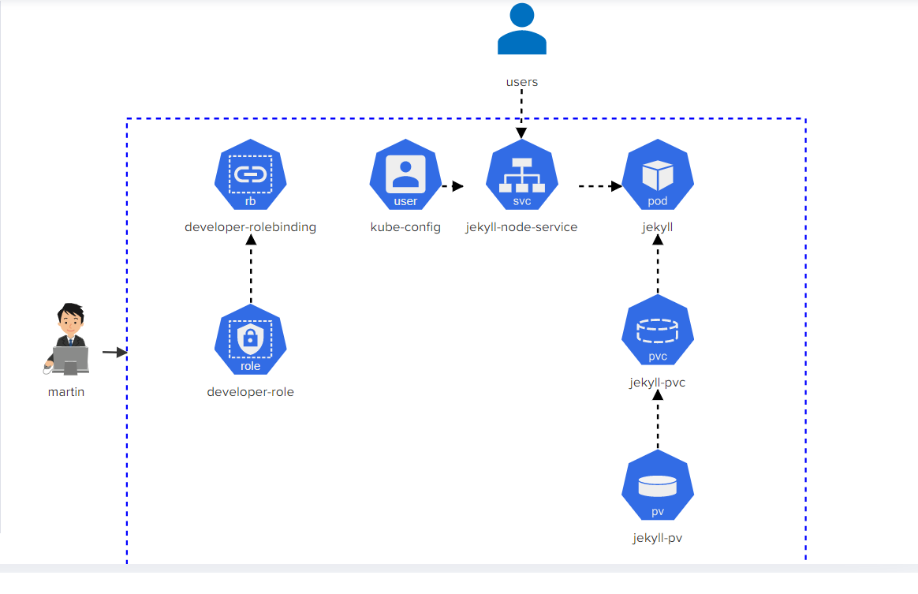

Problem 1

* Build user information for martin in the default kubeconfig file: User = martin , client-key = /root/martin.key and client-certificate = /root/martin.crt
* Create a new context called 'developer' in the default kubeconfig file with 'user = martin' and 'cluster = kubernetes'

Solution

<https://github.com/Sofoniasm/Kubernetes-challenge-/blob/main/create%20rolebinding.txt>

Problem 2

* create rolebinding = developer-rolebinding, role= 'developer-role', namespace = development
* rolebinding = developer-rolebinding associated with user = 'martin'

Solution

<https://github.com/Sofoniasm/Kubernetes-challenge-/blob/main/create%20rolebinding.txt>

Problem 3

set context 'developer' with user = 'martin' and cluster = 'kubernetes' as the current context.

Solution

<https://github.com/Sofoniasm/Kubernetes-challenge-/blob/main/create%20context.txt>

Problem 4

* Service 'jekyll' uses targetPort: '4000', namespace: 'development'
* Service 'jekyll' uses Port: '8080', namespace: 'development'
* Service 'jekyll' uses NodePort: '30097', namespace: 'development'

Solution

<https://github.com/Sofoniasm/Kubernetes-challenge-/blob/main/Expose%20pod.txt>

Problem 5

* pod: 'jekyll' has an initContainer, name: 'copy-jekyll-site', image: 'kodekloud/jekyll'
* initContainer: 'copy-jekyll-site', command: [ "jekyll", "new", "/site" ] (command to run: jekyll new /site)
* pod: 'jekyll', initContainer: 'copy-jekyll-site', mountPath = '/site'
* pod: 'jekyll', initContainer: 'copy-jekyll-site', volume name = 'site'
* pod: 'jekyll', container: 'jekyll', volume name = 'site'
* pod: 'jekyll', container: 'jekyll', mountPath = '/site'
* pod: 'jekyll', container: 'jekyll', image = 'kodekloud/jekyll-serve'
* pod: 'jekyll', uses volume called 'site' with pvc = 'jekyll-site'
* pod: 'jekyll' uses label 'run=jekyll'

Solution 5

<https://github.com/Sofoniasm/Kubernetes-challenge-/blob/main/Create%20pod.txt>

Problem 6

* Storage Request: 1Gi
* Access modes: ReadWriteMany
* pvc name = jekyll-site, namespace = development
* 'jekyll-site' PVC should be bound to the PersistentVolume called 'jekyll-site'.

Solution 6

<https://github.com/Sofoniasm/Kubernetes-challenge-/blob/main/Create%20PVC.txt>

Problem 7

<https://github.com/Sofoniasm/Kubernetes-challenge-/blob/main/get%20PV.txt>